**Ideation Phase**

**Empathize & Discover**

|  |  |
| --- | --- |
| Date | 14 April 2025 |
| Team ID | SWTID1743354369 |
| Project Name | House Rent App Using MERN – House Hunt |
| Maximum Marks | 4 Marks |

**Empathy Map Canvas:**

An empathy map is a simple, easy-to-digest visual that captures knowledge about a user’s behaviours and attitudes.

It is a useful tool to helps teams better understand their users.

Creating an effective solution requires understanding the true problem and the person who is experiencing it. The exercise of creating the map helps participants consider things from the user’s perspective along with his or her goals and challenges.

An **Empathy Map** is a collaborative visualization tool used to articulate what we know about a particular user type. It helps teams understand and align around the user’s perspective by breaking down their behaviors, thoughts, feelings, and needs. It is often used during the **ideation and discovery phase** of product development to build **user-centered solutions**.

Empathy maps help answer questions such as:

* What is the user experiencing?
* What are they thinking and feeling?
* What are their challenges and motivations?
* How can we best solve their problems?

### ****Application to HOUSE HUNT (House Rent App)****

In the context of your **house rental platform**, the empathy map becomes a **crucial UX tool** to understand the **tenant** (e.g., college students, working professionals) or **property owner** and their journey in renting or listing a property.

## ****Why is the Empathy Map Important for HOUSE HUNT?****

* Helps your **development team build features** that address real user concerns
* Aids in creating a **more intuitive and user-friendly UI/UX**
* Guides your **content and communication strategy** (e.g., what messages users respond to)
* Ensures your solution is **empathetic, practical, and user-centric**, not just technically sound

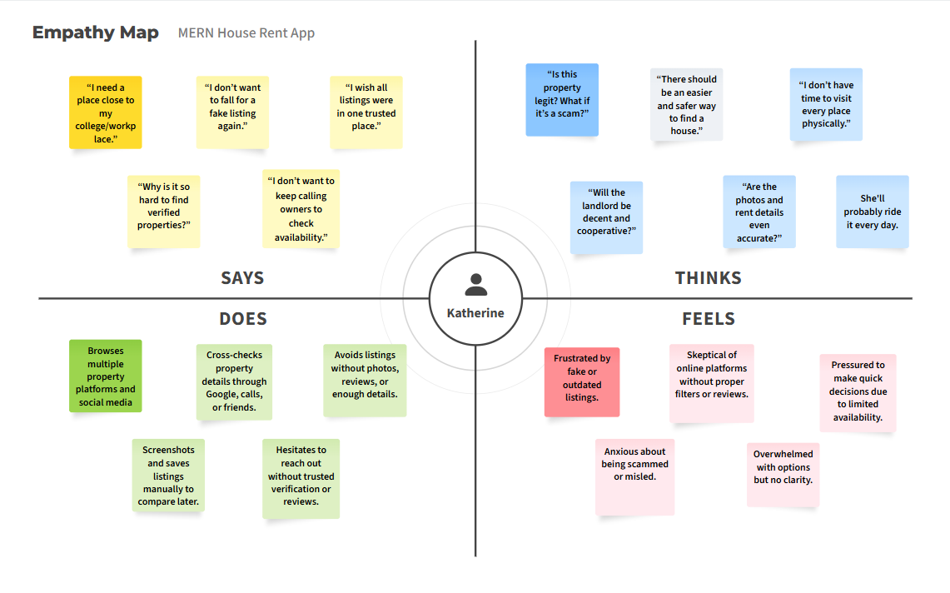

## ****User Needs (for Tenants)****

These are the essential desires or features that the user expects from a rental platform.

* Verified and trustworthy rental listings
* Filters for location, price, room type, etc.
* Real-time availability and updates
* Photos and accurate descriptions of properties
* Easy communication with landlords (chat/call)
* Mobile-friendly and easy-to-use interface
* Option to bookmark or save listings
* Reviews or ratings from previous tenants
* Transparent pricing (no hidden charges)

## ****Pain Points (for Tenants)****

These represent the challenges or frustrations that users commonly face with current platforms.

* Fake or scam property listings
* Outdated or inaccurate property details
* No centralized source of verified properties
* Poor user interface and complicated navigation
* Lack of direct communication with landlords
* No review system for landlords or properties
* Wasting time calling or visiting unavailable listings
* Security concerns during transactions or site visits